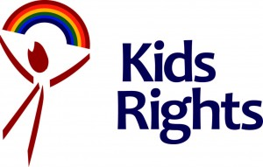
PRESS RELEASE

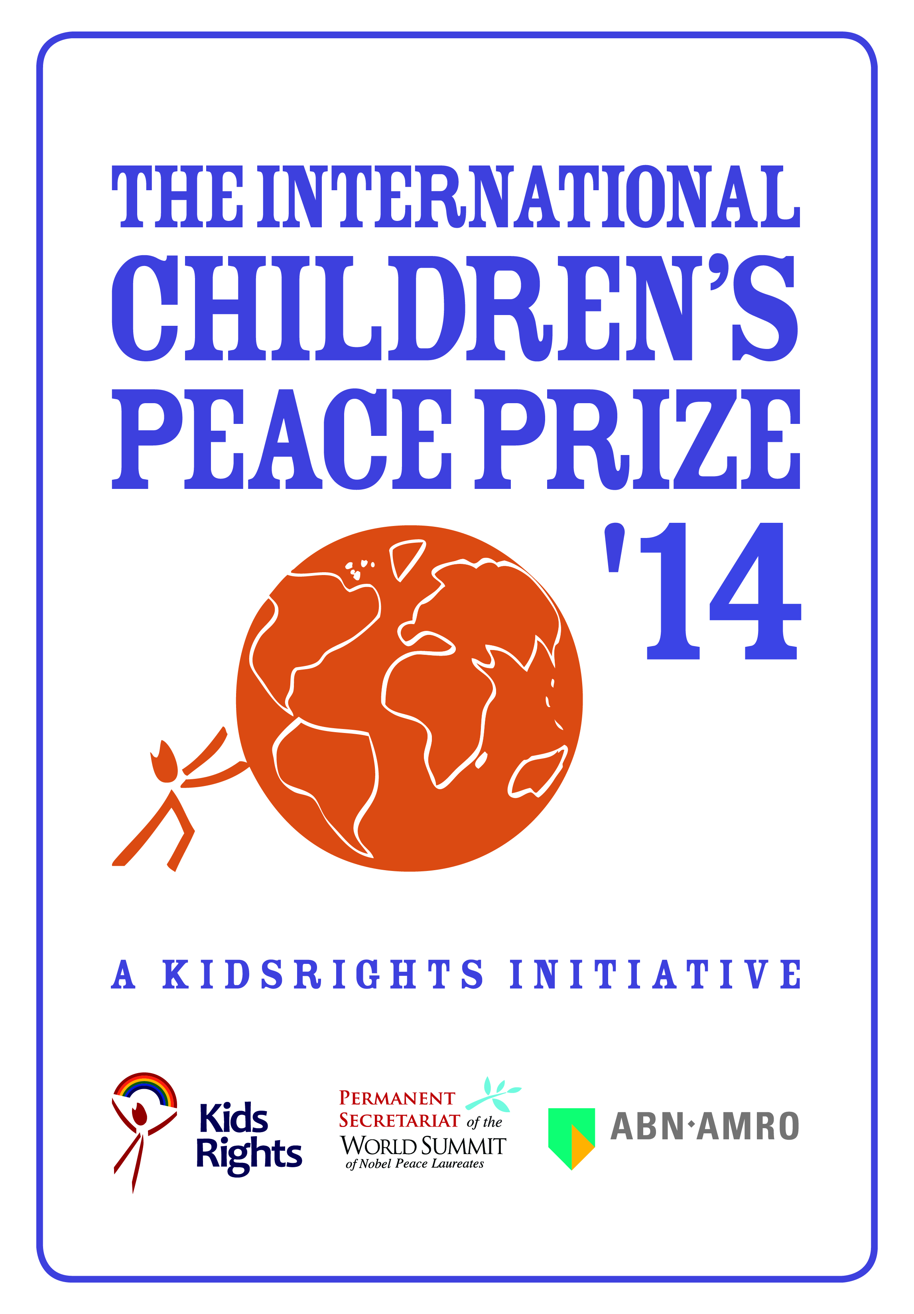
Alexey (17), Andrew (13) and Neha (18) nominated for the tenth International Children’s Peace Prize by KidsRights
Amsterdam, 25 September 2014 – Alexey from Russia, Andrew from Ghana and Neha from the United States have been nominated for the International Children’s Peace Prize 2014. The nominees have each shown special dedication to children’s rights. The International Children’s Peace Prize is an initiative of the children’s rights organization KidsRights and is being presented for the tenth time this year. The winner will be announced at the award ceremony on Tuesday November 18th. Desmond Tutu is travelling to the Netherlands especially to present the prize.

An independent Expert Committee has selected Alexey, Andrew and Neha from nominees all over the world. Marc Dullaert, chairman and founder of the KidsRights Foundation, says “Andrew, Neha and Alexey are a source of inspiration to both children and adults all over the world. They are the proof that children can make a difference.”
Alexey fights against the oppression of homosexual and transgender youth in Russia
Alexey (17) from Russia is the face of the battle against the discrimination of the LGBTI youth (Lesbian, Gay, Bisexual, Transgender and Intersexed). He is the driving force behind the project ‘Children-404’; an online community where young Russian homosexuals and transgenders can exchange experiences. Alexey himself is openly homosexual and knows how important this support is. When the initiator of the project was persecuted for homosexual propaganda, Alexey organized a protest campaign, through which he inspired other youngsters to follow his example. He has been attacked twice on the street, but nothing can stop him in his fight against oppression.
Ghanaian nominee Andrew organizes food aid projects in the fight against famine
Andrew (13) was eleven when he saw images of the famine in Somalia. He decided to take action to help these children. In the project Save Somali Children From Hunger, he collected money in the neighborhood and drew attention to the food crisis in the Horn of Africa. His activities did not go unnoticed, as he was soon invited to appear on radio and television. He is currently working on a food aid project to ensure that children in Ghana get three nourishing meals a day.
American nominee Neha helps children in need through her own foundation
Neha (18) lives in Philadelphia (US) and is of Indian descent. On an annual visit to her grandparents in India, Neha realized at the age of nine that orphans had fewer opportunities in life than she did. When she got home, she set up her own foundation: Empower Orphans. What started as a local fund-raising campaign grew into an organization that has now collected over 1 million dollars and helped 25,000 children in India and in her own country. Neha also inspires children in other countries to start up campaigns. So besides being a changemaker herself, she is also creating an international movement of changemakers.
10th anniversary of the International Children’s Peace Prize
On Tuesday November 18th, Nobel Peace Prize winner and KidsRights patron Desmond Tutu will present the International Children’s Peace Prize to the winner in The Hague (The Netherlands). The 10th anniversary of the prize will be celebrated by the publication of the book ‘Changemakers’, containing texts by, inspiring interviews with, and unique photographic material of the ten Children’s Peace Prize winners. It will be available as a limited edition directly after the presentation of the Children’s Peace Prize on November 18th.
- End of Press Release–
About the International Children’s Peace Prize
The International Children’s Peace Prize is awarded annually to a child who has shown special dedication to children’s rights. By awarding the International Children’s Peace Prize, KidsRights has been putting a brave child in the spotlight for ten years now. An independent Expert Committee selects the winner from nominees all over the world. The International Children’s Peace Prize is an initiative of Marc Dullaert, chairman and founder of KidsRights. The prize was launched in 2005 during the Nobel Peace Laureates’ Summit in Rome, chaired by Mikhail Gorbachev. Since then, the prize has been presented every year by a Nobel Peace Prize Laureate. The winner of the International Children’s Peace Prize receives the statuette ‘Nkosi’, which shows how a child sets the world in motion. The winner also receives a study grant and a world-wide platform to promote his or her ideals and causes to the benefit of children’s rights. A project fund of €100,000 that is made available through the AkzoNobel Children’s Peace Fund, is invested by KidsRights in projects that are closely connected to the winners’ area of work. Since 2006, ABN AMRO has been the main sponsor of the International Children’s Peace Prize. www.childrenspeaceprize.org
About the KidsRights Foundation
Every child has talents. Every child has dreams. KidsRights believes in a world where all children have access to their rights and are enabled to realize the great potential they have within them. The Dutch children’s rights organization sees children as changemakers, who can set the world in motion. KidsRights focuses attention on children’s rights with the aim of improving them. In order to gain insight into the status of children’s rights, KidsRights conducts regular research. The foundation also finances local projects aimed at improving children’s rights and stimulating child participation. This year, the International Children’s Peace Prize is being presented for the tenth time. The prize is one of the most important platforms facilitated by KidsRights. Desmond Tutu, Nobel Peace Prize winner and patron of KidsRights, says: “KidsRights seeks to give a voice to the voiceless”. www.kidsrights.org

Note to the editor (not for publication)
For longer biographies of the nominees, please contact FleishmanHillard or look at www.childrenspeaceprize.org. For information about interview opportunities, the book ‘Changemakers’, the presentation of the tenth Children’s Peace Prize and all the previous winners, please contact: <Insert local contact details>

