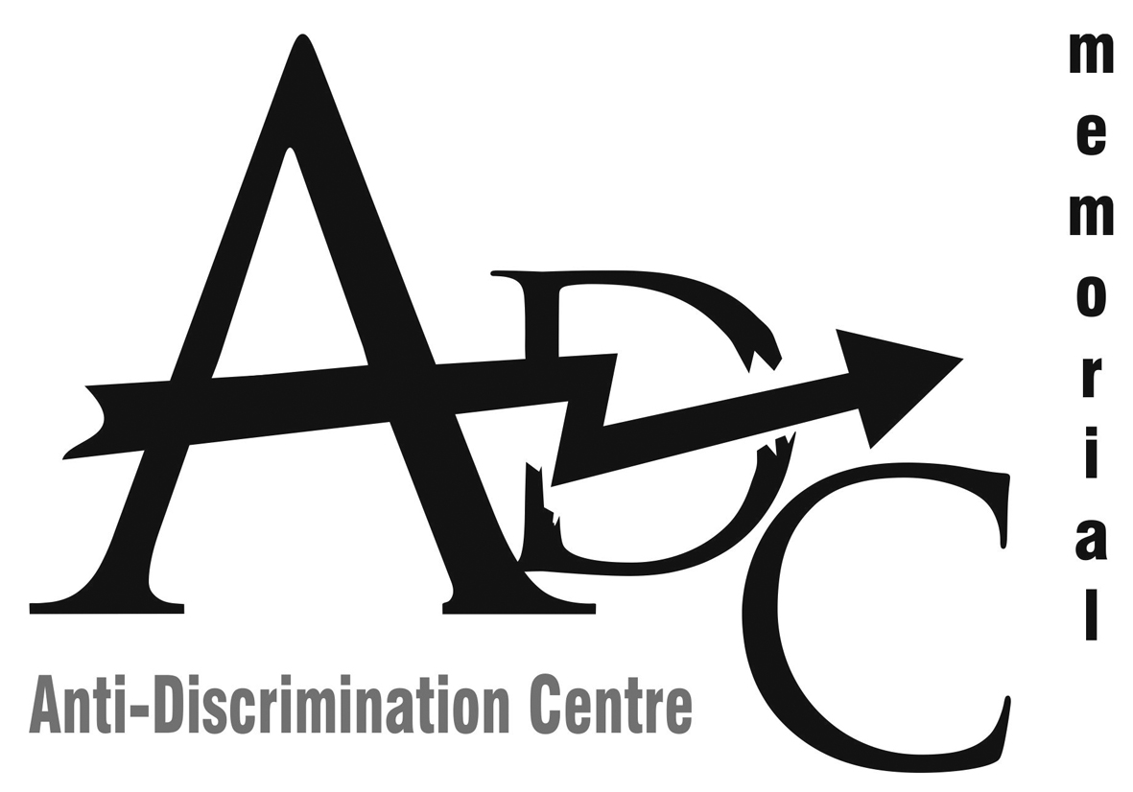 |  | 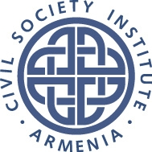

Anti-Discrimination Centre “Memorial”

Civil Society Institute

List of issues on discrimination and violation of rights of the vulnerable groups and women in Armenia
For the 65th Session of CEDAW UN (Pre-sessional Working Group, March 6-11, 2016)

Discrimination of women remains a widespread phenomenon in Armenia due to strong patriarchal traditions (especially in the rural areas), a lack of anti-discrimination legislation as well as the implementation of existing norms of gender equality. A good example of existing understanding of prestige of the male gender can be the fact that in many families women are still forced to go through a medical ultrasound investigation of their pregnancy and if the future child proves to be a girl, the family would insist on abortion as boys are valued much higher than girls. It is also clear that women are underrepresented in parliament and governmental bodies, especially in leadership positions. The salaries of women also significantly differ and remain lower than those of men. In rural areas, most of women are unemployed and remain housewives, supposed to be always home and do all domestic work. A significant problem for mothers remains the lack of kindergartens as over 80% of pre- school age children stay at home with their mothers. The most aggravating aspect of all kinds of discrimination remains poverty, as most families in Armenia are still extremely poor. The situation is especially dramatic for women from vulnerable minorities, who sometimes face multi-discrimination and for women in migration.

Women and Migration

- Working migrant women and members of working migrants families

Armenia is a migration donor country : there are not enough jobs for people in the country and many Armenians go on to work in migration in order to earn a living for themselves and their families. The main destination of the working migration from Armenia remains the Russian Federation. According to the migration service of Armenia, all in all, 1 million Armenians work in Russia and several 100.000’s regularly cross the border for season work migration. However, because of economic crisis in Russia and growing blacklists of “unwanted persons in Russia”, it becomes more and more difficult to benefit from working migration . All of this, heavily affects the situation of women, both of those who go in migration themselves and of those who stay at home while their husbands work in Russia.
In many villages, most of men can find jobs only in Russia and are forced to leave their families. However, often when they have been for some time away, they cannot send money home anymore, which leaves women and children in an extremely difficult economic situation as women cannot get employed in the total unemployment situation and totally depend on the men who are far away. Another aspect of the problem of migration is the situation of the women who made money in Russia themselves, but who had to come back to Armenia and cannot go into migration again, because they ended up on “the list of unwanted persons” or have other circumstances. These women have big difficulties to adapt to the poor and restricted-by-traditions Armenian villages and to find their way to survive economically. However, there are no state programs in Armenia for the integration of returning working migrants and no strategy for solving the problems of such women.

- Refugees from Syria and Iraq
In the recent years, a number of serious crises and even wars happened in the countries near Armenia that caused a flow of refugees. Armenia accepted dozens of thousands of refugees originating from Syria and Iraq of Armenian ethnic origin and Christian belief. However, all other refugees including those of Yezidi, Muslim or non-Armenian origin got refused refugee status in Armenia. As Armenia is bordering the region of conflicts, it is supposed to give refugee to all persons in need for it, regardless their religion, ethnic origin and gender.

- Women-victims of trafficking
Poverty and high level of unemployment often force women into looking for jobs abroad, what sometimes leads to them falling victim to trafficking and even sexual trafficking. Experts on migration repeatedly reported about Armenian girls and women sent to Middle Eastern countries for sexual exploitation. Often, they are deprived from personal freedom, access to their documents and the ability to return. Widespread prejudice against sexual workers and victims of sexual exploitation and rape make it especially difficult for these women to address their families and communities for help. The investigation of sexual crimes against women is often not carried out carefully enough and it is still not the rule that women investigators have to talk to the victims.

Discrimination of vulnerable groups

- Ethnic and Religious Minorities
Although more than 90 % of the population of Armenia are ethnic Armenians and an even higher percentage belongs to the Armenian church, there are still groups and communities of minorities such as Assyrians, Kurds, Yezidi (also called Ezidi, Yazidi), Bosha (Romani group) and Molokani (religious minority). Communities of these minorities are often isolated from the rest of the population and practice their traditional ways of life. For example, the Yezidi communities still practice early marriages and arrange marriages of girls of 15-16 years old. It is clear that the opinion of the girls is usually not important for the arrangement and further, these young brides are taken away from school and will be unable to complete their education. Some other communities also remain very patriarchic in their way of raising girls and in the position given to women in their families. However difficult it is to combine respect to minority rights and efforts to support emancipation of the women and girls from the minority groups, it is really important to give state support to the education of women and girls and to control the equality of all groups in access to school and further employment.

- Women facing discrimination on the basis of sexual orientation and gender identity
In Armenia, the rights of lesbian, bi-sexual and trans-sexual women and intersexuals are still not guaranteed by the legislation. In practice, most of them face problems with self-expression and have to hide their identity in their families and communities. In the Public sphere, hate speech against them is still widespread. Homophobia and Transphobia are incited by some websites and even lists of LGBTI teachers are published with a call to exclude them from the education system. Many LGBTI persons fall victim to hate crime (unofficial statistics for 2015 : 45 cases), however, no-one hate crime against LGBTI has been registered as such by the police officers and investigators. Meanwhile, the state officials and police officers never come to the trainings against hate crimes and hate speech organized by LGBTI organizations.

Conclusions and recommendations

It is important to take special measures to overcome widespread discrimination of women, patriarchal prejudice and inequality of women in access to basic rights such as education, employment and political participation, protection against violence and insults. It is also necessary to oppose the growing impoverishment of women in rural areas and women in migration. The Armenian state has to develop a strategy in reintegration of women ex-working migrants and support their new start-up in Armenia. The women, who remain alone with their children because of the work migration of their husbands should also be included in the strategy in order to provide them with an alternative from the dependence on the income of their husbands. There should be special measures to prevent trafficking and sexual exploitation of Armenian women as well as modern system of rehabilitation of victims of sexual crime and violence.
Vulnerable communities should get special attention and support. The comprehensive anti-discrimination law should be adopted where ethnic, religious and sexual minorities should be included with special mechanisms on protecting them against hate speech and hate crime. There should be an effective mechanism of control to guarantee access of all girls from traditional communities to school to prevent drop-outs because of arranged marriages, to give every girl the chance to get full education and consequently proper employment. Meanwhile, the rights of ethnic and religious minority women to voluntarily carry out religious and cultural activities should be secured and respected.

